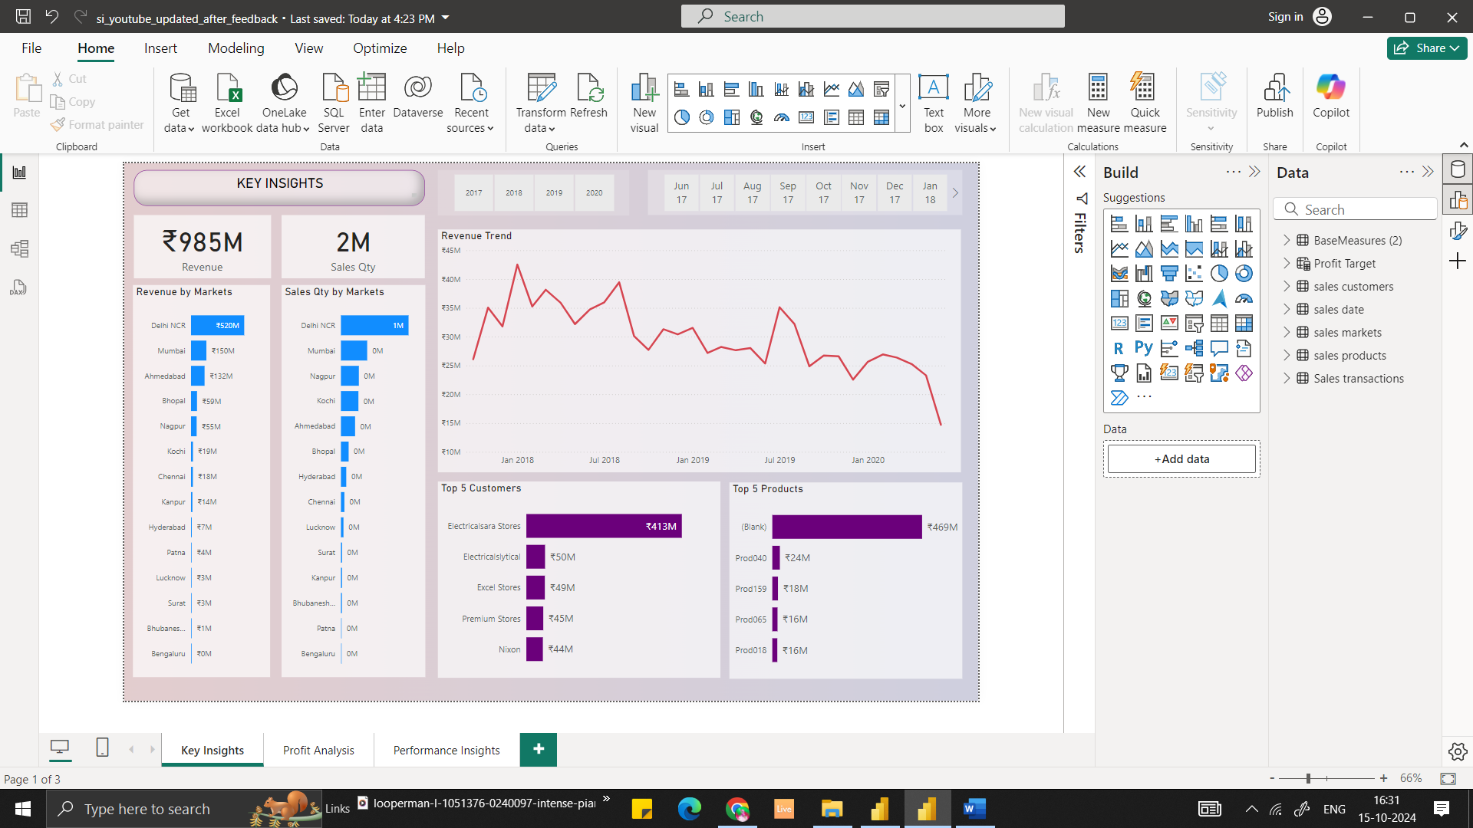

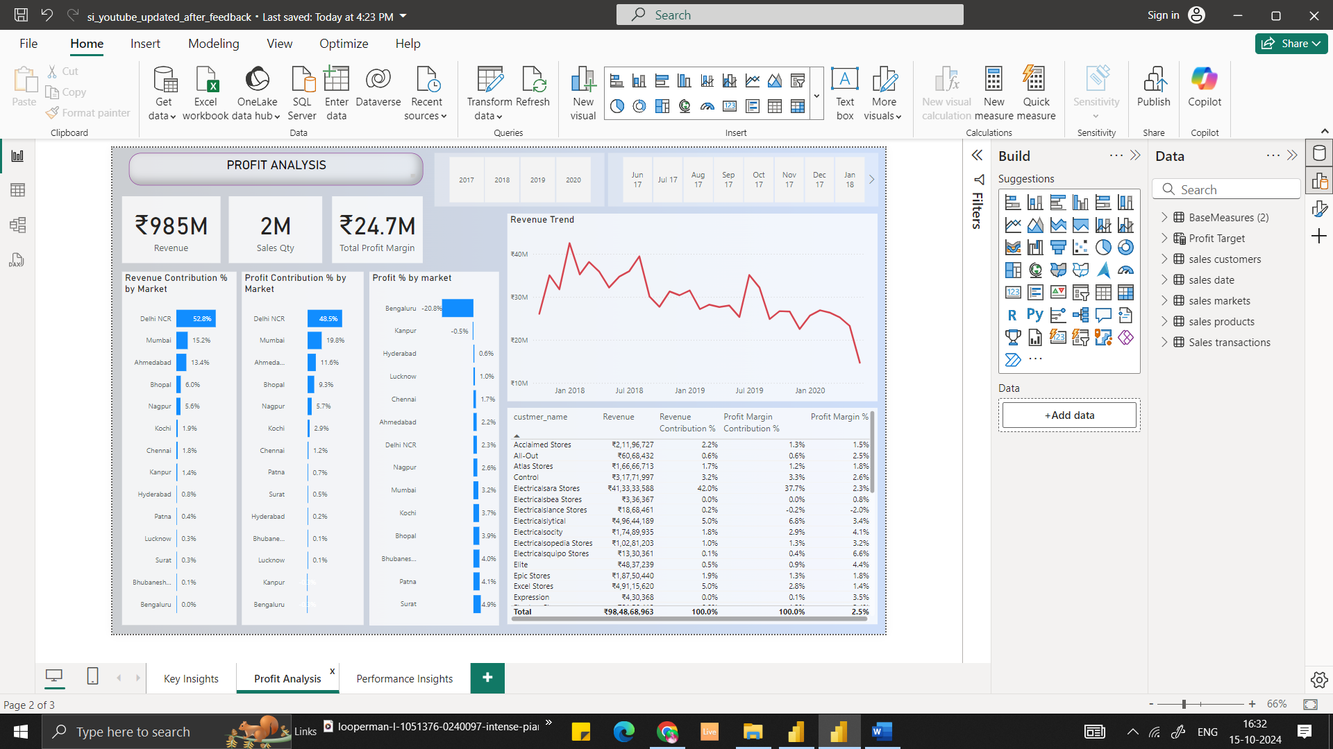

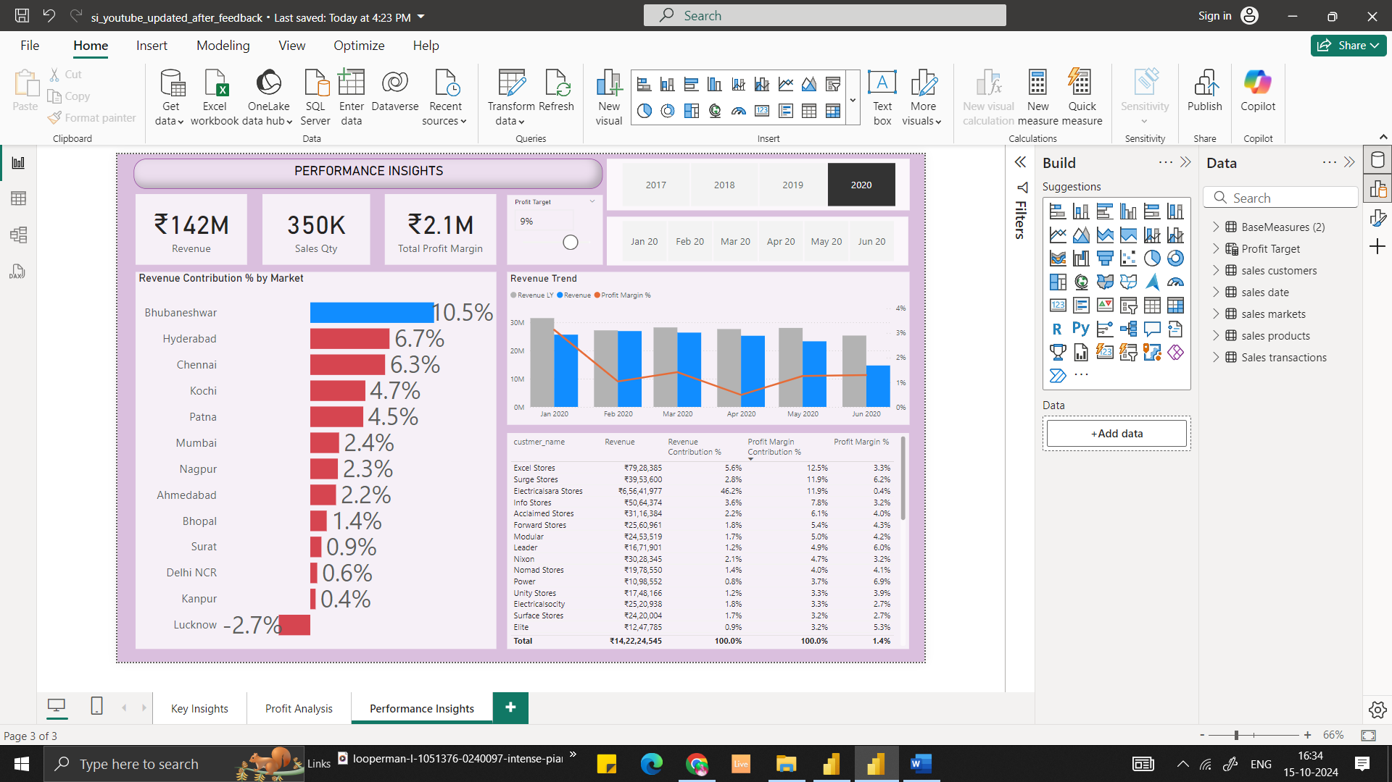  
  
  
  
Kmart Data  
  
**Purpose**The goal of this project is to uncover sales insights that were previously not visible to the sales team, enabling better decision-making. Ultimately, we aim to provide a dashboard that delivers the latest sales insights to support data-driven decision-making.

**1. Data Preparation**The project utilized a SQL database, where some exploratory data analysis (EDA) was performed to ensure the accuracy of the metrics provided by Power BI.

**2. Dashboard Development**I conducted ETL (Extract, Transform, Load) processes and extensive data cleaning in Power BI. This included resolving numerous columns with identical values but differing numbers, as well as removing duplicate transactions by using unique IDs for identification.

I began by creating cards for key metrics such as Revenue and Sales Quantity, followed by charts to visualize these metrics. Additionally, I included charts for the top customers and products, which are essential for understanding sales dynamics. A line chart was added to depict revenue trends over time.

To enhance usability, I duplicated functions to feature the same metrics across different dashboards, focusing on Profit and Performance, respectively. These dashboards included state-level charts to highlight the highest and lowest revenue-generating areas. Finally, I incorporated a chart in the performance insights section to show revenue contribution percentages in relation to the market.

**3. Insights and Recommendations**The analysis revealed that the bottom two products are not frequently discounted. Furthermore, certain regions are experiencing a rapid decline in business, as indicated by the yearly trend lines. This decline may be attributed to increased competition or other factors, and it warrants further investigation.

Additionally, the months of February and April showed lower sales. To address this decline, I recommend implementing promotional offers or discounts during these months to stimulate sales.